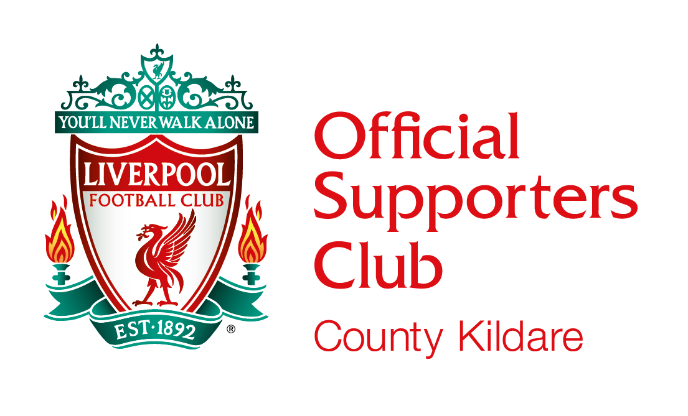
Membership Application (Season 2021 / 22)
The County Kildare Liverpool Supporters Club is affiliated to the association of International Branches. Branch meetings will be held in Coffey’s Bar in Newbridge Town to which prior notification of dates / times will be communicated to members, where we will meet up for LFC Live games, discuss upcoming events and other branch issues as necessary.

Adult Membership: €0.00 per Season )
Under 18: €0.00 per Season ) Currently No Membership Charge. To be Reviewed Monthly
Family: €0.00 per Season (2 Adults & 3 Kids) )

Any Member wishing to travel to a game must have a current Official OLSC Membership. Application for Tickets will not be accepted without same. Tickets / Cards are Non-transferable, any Member found to be in breach of this Rule will be expelled from the Supporters Club.

All Members must reside in County Kildare. We cannot accept any Applications from outside County Kildare in line with the Official Liverpool Supporters Club Rules.

The annual Membership entitles each Member to the following benefits:
- Opportunity to be part of an official Liverpool FC supporters club.
- Access to branch social events & Club Clothing Range at discounted prices.

The branch has a dedicated website which can be found at: www.cklsc.ie where you can also find the link to our Clubs Facebook Page.
Completed membership forms should be emailed to our Club Email Address - info@cklsc.ie (Bank Details available upon request).

Bank Transfer payable to Kildangan / Nurney Liverpool S.C. IBAN: IE 06 AIBK 9336 2714 5260 94
Membership runs from 1st August 2021 up to and including 31st July 2022.
Applicants Information
Surnames |  | First Names |  |  | Dates of Birth
Address
Town/City |  | County
Phone No: (Landline) |  | E-mail Address
Phone No: (Mobile) |  | OLSC Members No:

By Signing this Form you agree to abide by our Club Constitution and Branch Rules, copies of same can be found on our Club website (www.cklsc.ie)

SIGNED : ______________________________ DATE : _____________________

